**BinaryTree.cpp**

**Errors:**

1. Some pointers error
2. 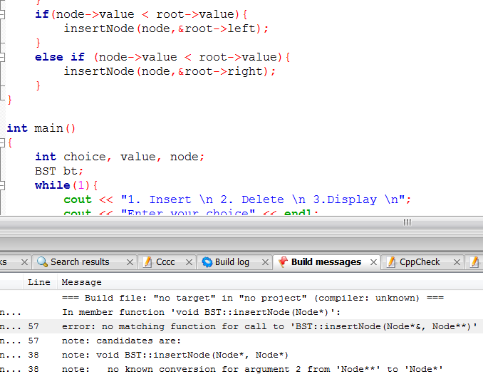
3. What’s this error?
   1. When you declare Node *node 🡪 this means node is a pointer which points to custom data type Node.
   2. Node *root